**Border padding and**



**Padding :-padding is the attribute which will make the padding between the element and the border.**

border by increasing the space from outside.**

Values given in this are clockwise , as border -width has four values so 1st for top , second for right, third for bottom and fourth for left . it’s in clockwise direction, we can also give two values so the first value will indicate the top and bottom and the the second value will indicate the left and right .

If we give one value then it will consider all the four to take the values.



To create a box in html element there is an element that is <div></div> element.

<div>:- This html element will create the invisible box and this box we can give our contents like image , text , videos etc.

This tag is used mostly. Its use is to sepeare the different content and group that content as the user wants

Some times debugging the division elements and CSS make quite difficult , so there is a chrome extension which will enables us to debug our css code easily ,

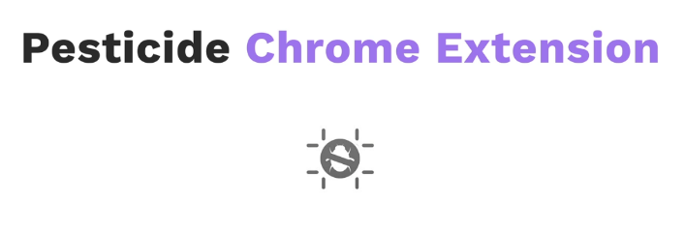It’s pesticide

After that activate this extensions nad use press ctrl kewyowrd and hold it and then hover the cursor to you webpage , down below it will show you the tags and the elements used in this box.



* Margin-block-start :- The **margin-block-start** [CSS](https://developer.mozilla.org/en-US/docs/Web/CSS) property defines the logical block start margin of an element, which maps to a physical margin depending on the element's writing mode, directionality, and text orientation.
* Margin-block-end:- The **margin-block-end** [CSS](https://developer.mozilla.org/en-US/docs/Web/CSS) property defines the logical block end margin of an element, which maps to a physical margin depending on the element's writing mode, directionality, and text orientation.

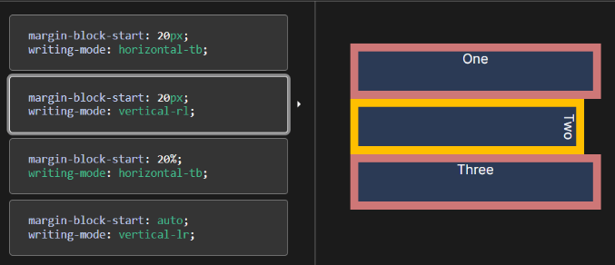

90000



Same for margin-block-end it will do it from bottom

So, for information visit <https://developer.mozilla.org/en-US/docs/Web/CSS/margin-block-start>

Text transform CSS property :-

